NAME: KHANYA NGEMA
STUDENT NUMBER: 20240948 SDT 621 – PM 04

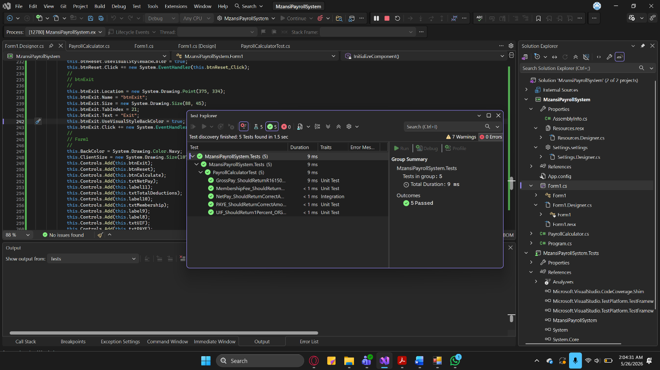
RUNNING THE APP AND TESTING USING TESING EXPLORER WITH ALL TESTS PASSED

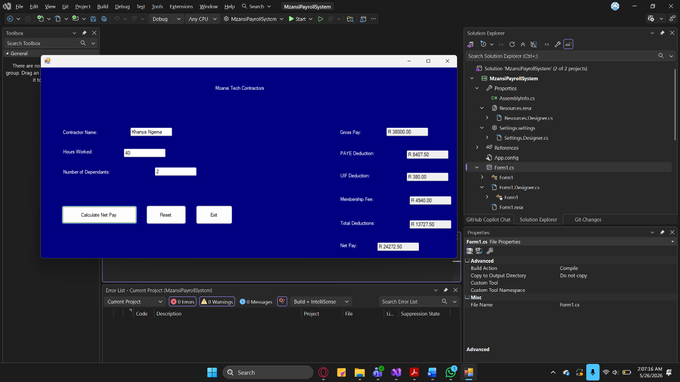
APP RAN WITH RESULTS TO SHOW ON THE RIGHT HAND SIDE

TESTING VALIDATION IN THE THREE FOLLOWING SCREENSHOTS:
- Hours not being able to be negative number.
- Contractor name needs to be there and dependants can only be 0-15
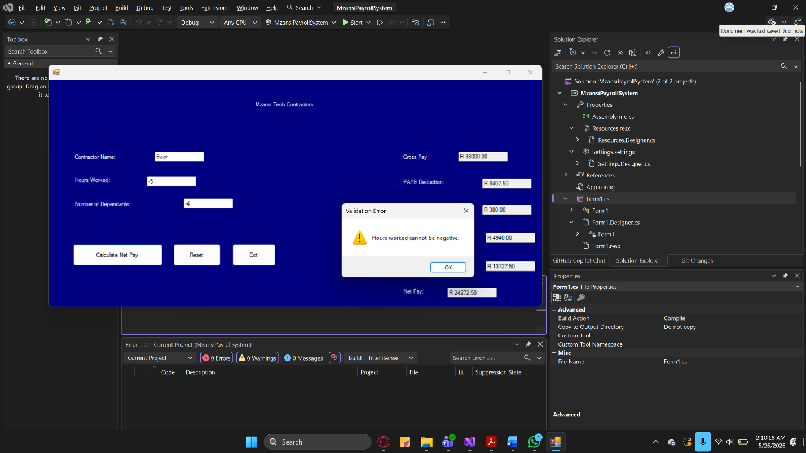
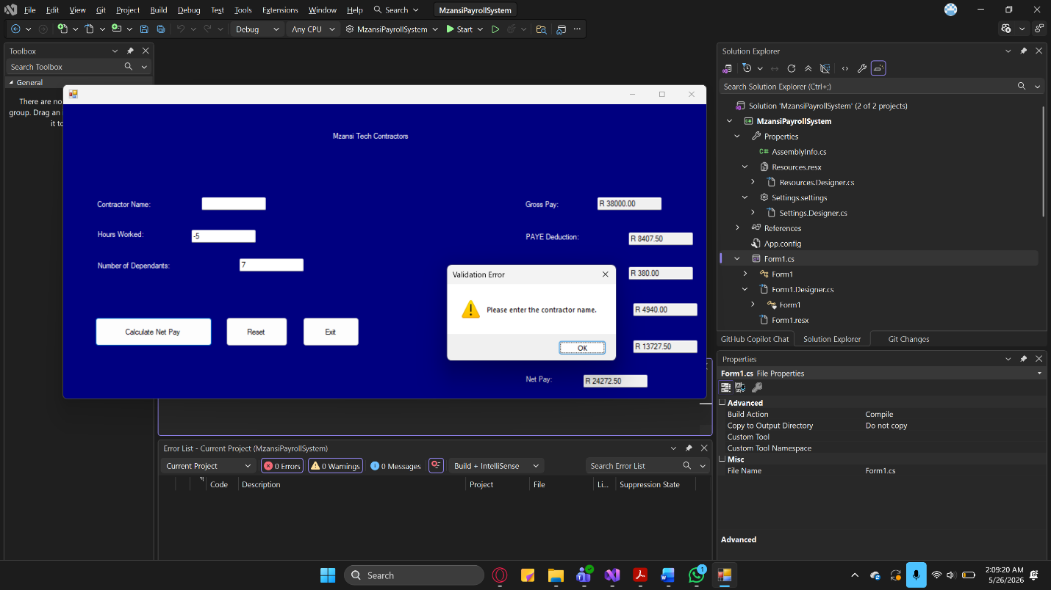
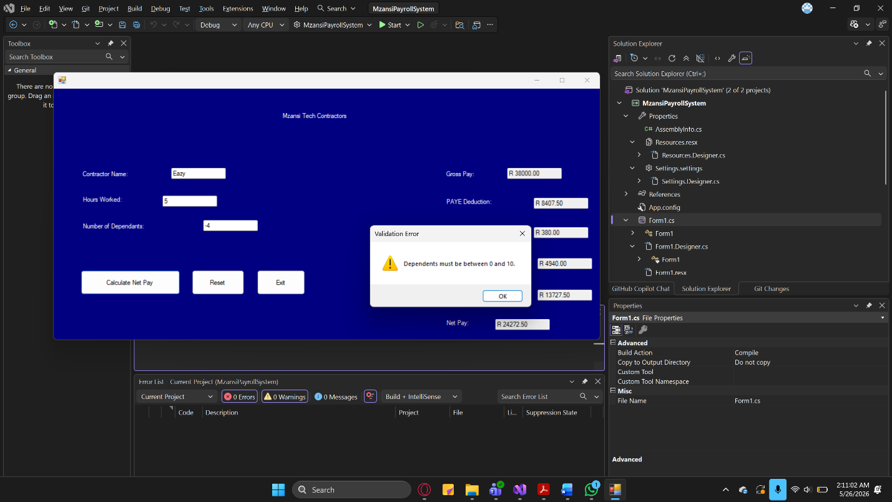

1. UNIT TESTING
Test Case | Input | Expected Output | Result
Gross Pay | 40 Hours | R38 000 | PASS
UIF | Gross R38 000 | R380 | PASS
Membership Fee | Gross R38 000 | R4 940 | PASS
PAYE | Gross R38 000, 2 Dependents | R8 407.50 | PASS
Net Pay | All above Combined | R24 272.50 | PASS

2. INTEGRATION TESTING
- Hours entered by the user are correctly passed into the gross pay calculation
- Gross pay is correctly passed into UIF, PAYE and membership fee calculations
- All deductions are correctly combined to produce the net pay

3. SYSTEM TESTING
Step | Action | Expected Result
1 | Launch the application | Form opens with all fields empty
2 | Enter name, hours, dependents and click Calculate | All output fields display correct values
3 | Enter negative hours and click Calculate | Error message appears
4 | Leave contractor name empty and click Calculate | Error message appears
5 | Click Reset | All fields clear completely

Defect ID | Description | Fix Applied | Retest Result
D001 | Button click events had wrong method names | Corrected event names in Designer.cs | PASS
D002 | textBox1_TextChanged attached to txtDependents incorrectly | Removed the event | PASS
D003 | Form1_Load referenced a non-existent method | Removed the Load event | PASS
4. DEFECT LOG TABLE

5. REGRESSION TESTING
After fixing the button click event names and remove incorrect events from the designer file, all five-unit tests were re-run and passed successfully. The reset and exit buttons now function correctly. No previous tests were broken by the fixes applied.

GITHUB LINK: https://github.com/khanyactu/MzansiPayrollSystem

